Crimes in Philadelphia

Team 3

**Data Science Capstone Project   
Exploratory Data Analytics Report**

Date:

02/15/2021

Team Members:

Name: Raj Patel

Name: Hong Son

Name: Kunal Sharma

[The purpose of this report is to describe the exploratory data analytics. It includes five major sections:

1. Analyzing the basic metrics of variables: data types, size, descriptive statistics
2. Non-graphical and graphical univariate analysis: identifying unique value and counts, histogram, box plots, etc.
3. Missing value analysis and outlier analysis
4. Feature engineering and analysis: correlation analysis, dimensionality reduction, deriving new variables
5. Appendix]

**Analysis the basic metrics of variables**

[In this section, we identify all the variables in the dataset and conduct the basic metrics of the variables. What are the data types (numerical/categorical, discrete or continuous, ordinal or nominal) and size? Provide the descriptive statistics of the variables such as mean, standard deviation, min, max, percentiles, etc.]

**Philadelphia Crimes**

|  |  |  |  |
| --- | --- | --- | --- |
| **Field Name** | **Alias** | **Description** | **Type** |
| DC_Dist | District | A two character field that names the District boundary. | int64 |
| DC_Key | DC Number | The unique identifier of the crime that consists of Year + District + Unique ID. | int64 |
| Dispatch_Date_Time | Dispatch Date/Time | The date and time that the officer was dispatched to the scene. | object |
| Hour |  | The generalized hour of the dispatched time. | int64 |
| Location_Block | Location Block | The location of crime generalized by street block. | object |
| Sector | PSA | A single character field that names the Police Service Area boundary. | object |
| Text_General_Code | General Crime Category | The generalized text for the crime code. | object |
| UCR_General | UCR Code | The rounded crime code, i.e. 614 to 600 (More info at<https://metadata.phila.gov/#home/datasetdetails/5543868920583086178c4f8e/representationdetails/570e7621c03327dc14f4b68d/)> | float64 |
| Police_Districts | Police Districts | The police district number | float64 |
| Lon | Longitude | the angular distance of a place east or west | float64 |
| Lat | Latitude | the angular distance of a place north or south of the earth's equator | float64 |

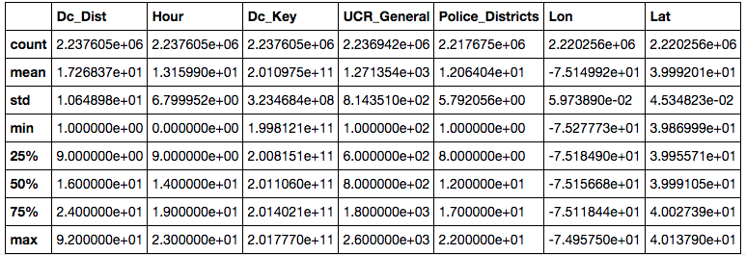

**Weather**

|  |  |  |  |
| --- | --- | --- | --- |
| **Field Name** | **Alias** | **Description** | **Type** |
| Date |  | The date of the collection | object |
| High Temp. | High Temperature | The highest temperature recorded that day | float64 |
| Low Temp. | Low Temperature | The lowest temperature recorded that day | float64 |
| Avg Temp. | Average Temperature | The Average temperature of the temperatures recorded | float64 |
| Temp Departure |  |  | float64 |
| HDD | heating degree day | A heating degree day (HDD) is a measurement designed to quantify the demand for energy needed to heat a building. | float64 |
| CDD | Cooling degree day | A cooling degree day (CDD) is a measurement designed to quantify the demand for energy needed to cool buildings. | float64 |
| GDD | growing degree days | Corn growing degree days (GDD) are calculated by subtracting the plant's lower base or threshold temperature of 50 °F (10 °C) from the average daily air temperature in °F or °C. | float64 |
| Avg Dewpoint | Average Dewpoint | The dew point is the temperature to which air must be cooled to become saturated with water vapor. | float64 |
| Avg RH | Relative humidity | Relative humidity (RH) is the ratio of the partial pressure of water vapor to the equilibrium vapor pressure of water at a given temperature. | float64 |
| Avg Wind Speed | Average Wind Speed | The Average Wind Speed of the wind recorded | float 64 |
| Avg Wind Dir | Average Wind Direction | The Average Wind Direction of the wind recorded | float64 |
| Avg Press |  | Atmospheric pressure, also known as barometric pressure, is the pressure within the atmosphere of Earth | float64 |
| Total Precip |  | NOTE: "Trace" amounts are defined as less than half that amount (0.005 inch). | object |
| Num Observations |  | The total number of observations for that day | float64 |

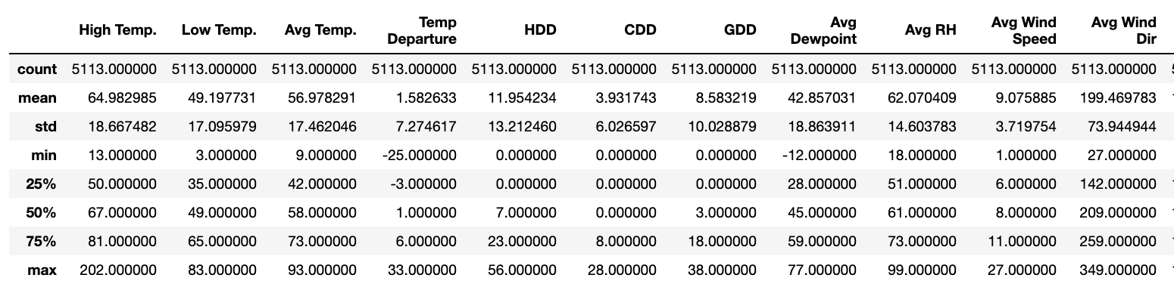

**Philadelphia Parking Violations**

|  |  |  |  |
| --- | --- | --- | --- |
| **Field Name** | **Alias** | **Description** | **Type** |
| zip_code |  | The date of the collection | object |
| issue_datetime |  | The highest temperature recorded that day | float64 |
| state |  | The lowest temperature recorded that day | float64 |
| violation_desc |  | The description of the violation | object |
| fine |  | Fine amount for the violation. | float64 |
| issuing_agency |  | The agency that issued the violation. | object |
| lon |  | the angular distance of a place east or west | float64 |
| lat |  | the angular distance of a place north or south of the earth's equator | float64 |
| location |  | Location at which the violation was written, | object |
| year |  | The year in that the violation occured | int64 |
| date |  | Date and time the violation was written. | Date/Time |

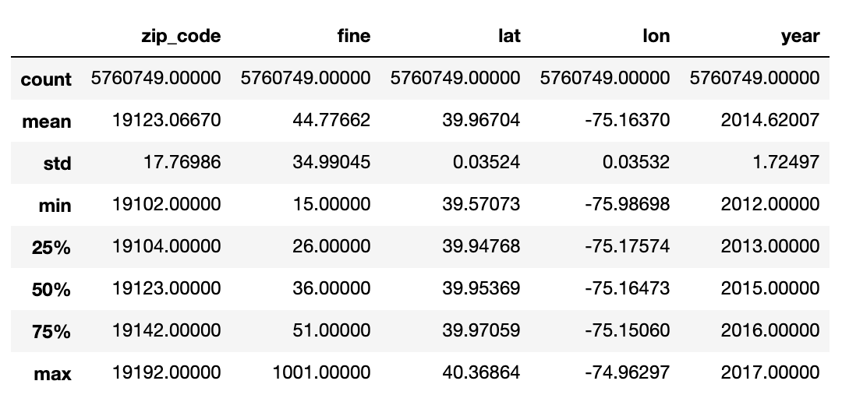

**Non-graphical and graphical univariate analysis**

[In this section, we identify the list and number of unique values for each variable and provide the histogram and box plots to understand the distribution of the data.]

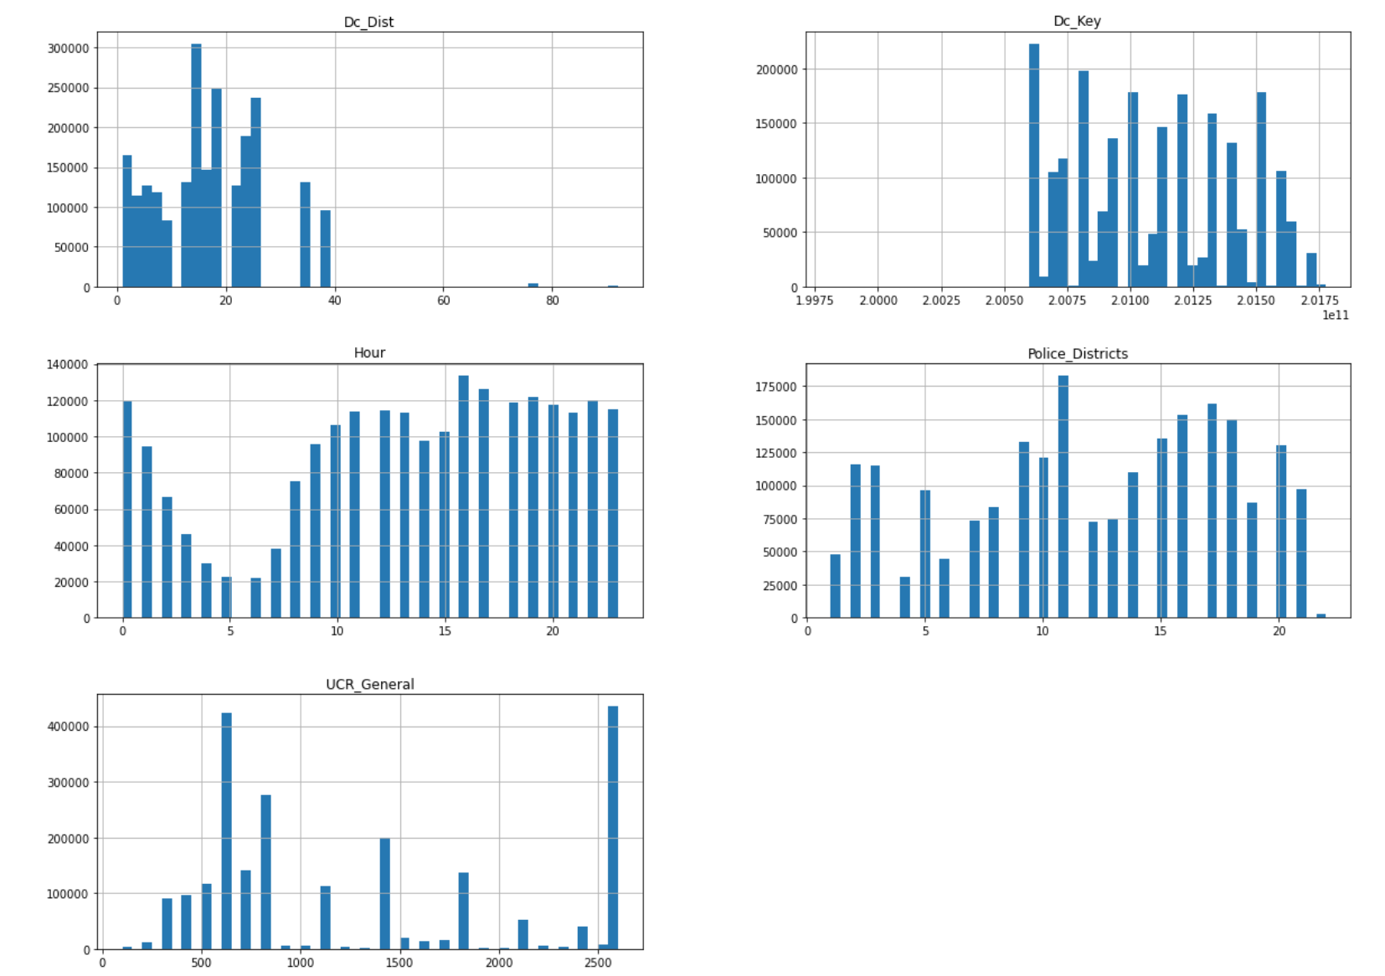

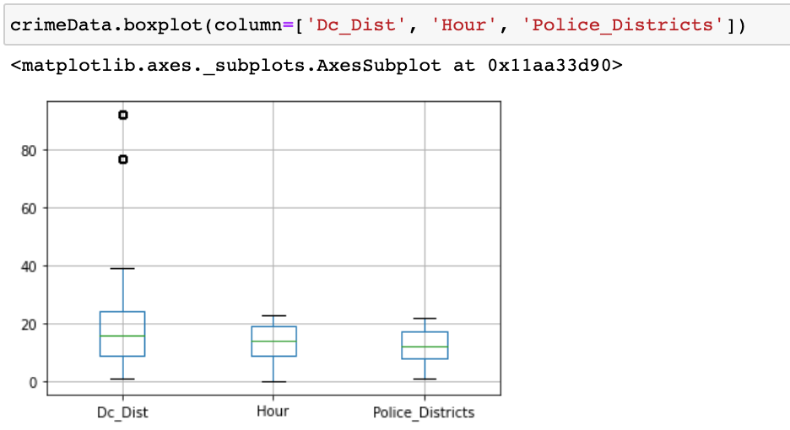

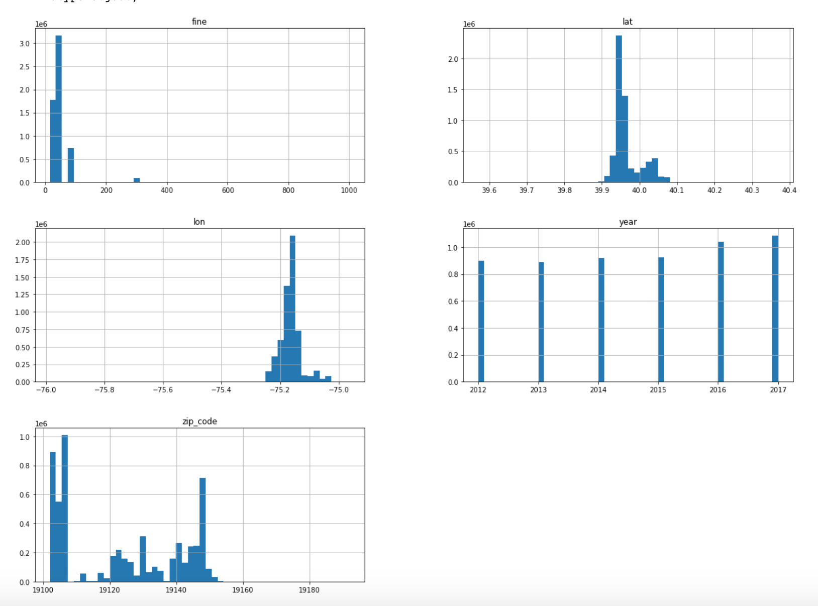

**Missing value analysis and outlier analysis**

[In this section, we identify the missing values and outliers and determine how we handle these values before analysis.]

We found missing values for the following columns:

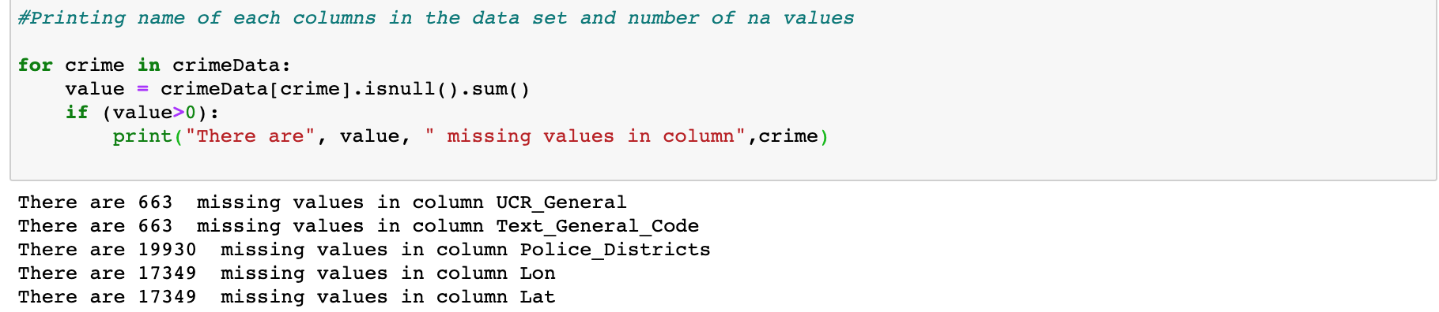

After reviewing the data, we determined to remove the rows with values with nan on geo location [lat, lon].

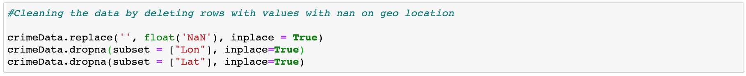

For missing values on the columns, we mainly just removed the rows with missing values [1]. They make up a small portion of the entire dataset (<1%).

For our weather data, we were missing values for total precipitation but that made sense as missing values indicated no precipitation. Values of TRACE were converted to the value 0.001 to indicate that there was very little precipitation but not that there wasn’t any.

The parking violations data had no missing value for lat, lon, and zip code. After merging with the crime and weather dataset, only 6067 rows had missing zip codes. This is a small amount of the data that we just discarded.

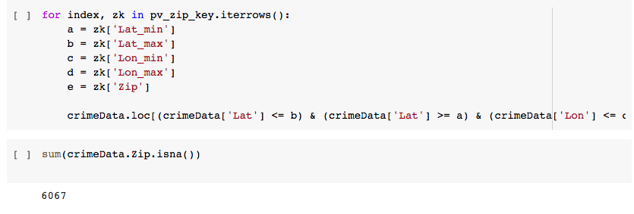

**Feature engineering and analysis**

[In this section, we identify the variables that are useful for predictive modeling and machine learning through correlation analysis. You may also reduce the dimension or derive new variables so that the predictive modeling can be more efficient and effective.]

To predict a certain type of crime that might occur given a user specified location and day of the year we have performed the following.

We are using Google’s cloud API to gain the geolocations of any user specified location within Philadelphia in real time.



Philadelphia has more than 500,000 different points of geo-location and therefore once we gained the geo-location above we are also considering 500 nearest locations from the crime data set. To gain the nearest locations we are using k nearest neighbor from sklearn. [4]



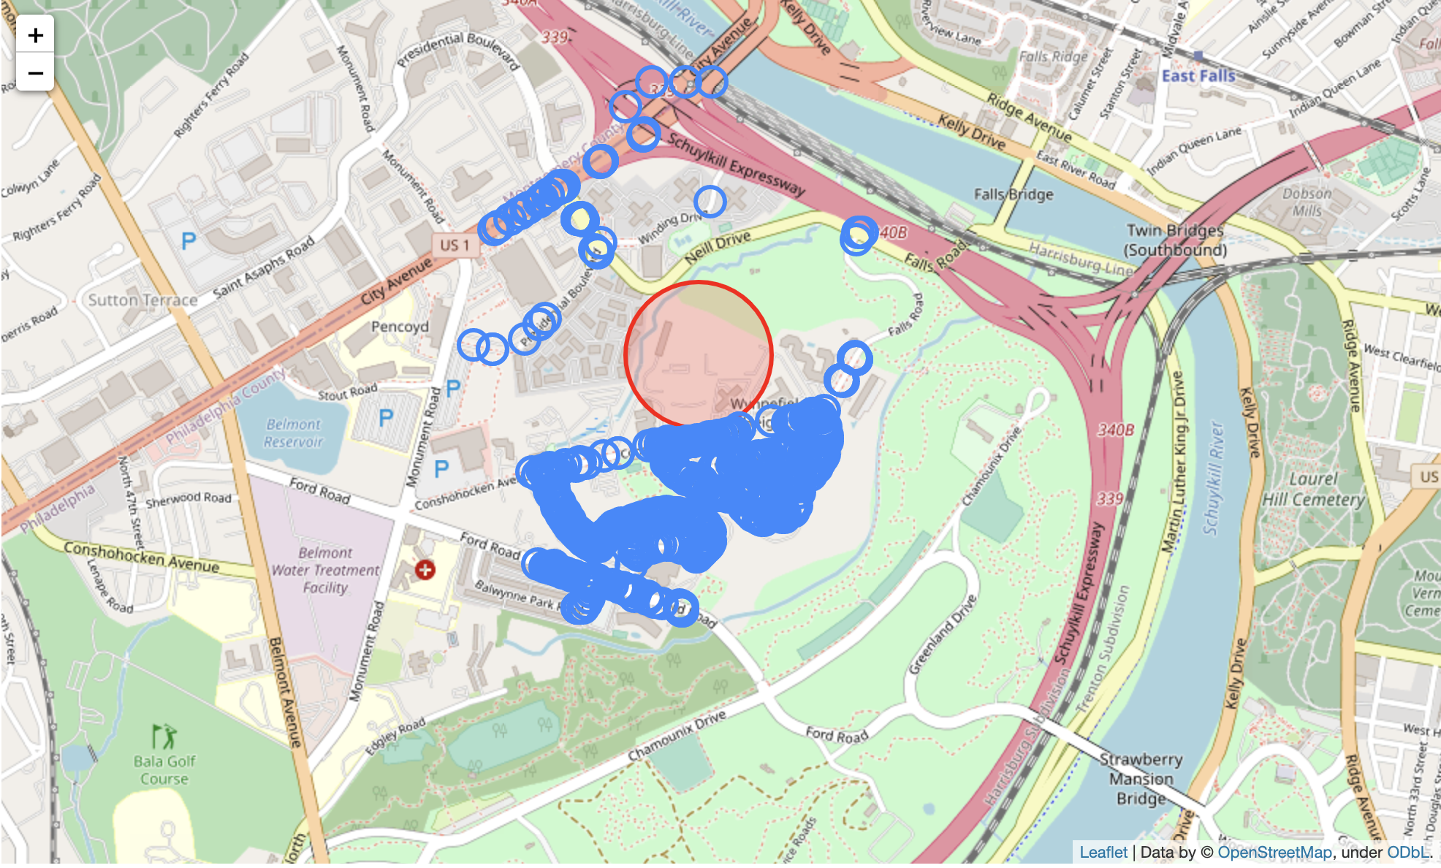

The above image contains the location that we focused on with a red marker and the nearest 500 different locations where crimes have occured in the past years from our dataset.

Since we want to focus only on the user specified day of the year, we filtered our dataset to have only the day (eg: Nov 11th) for each year in the dataset that we are using and the nearest locations from above.

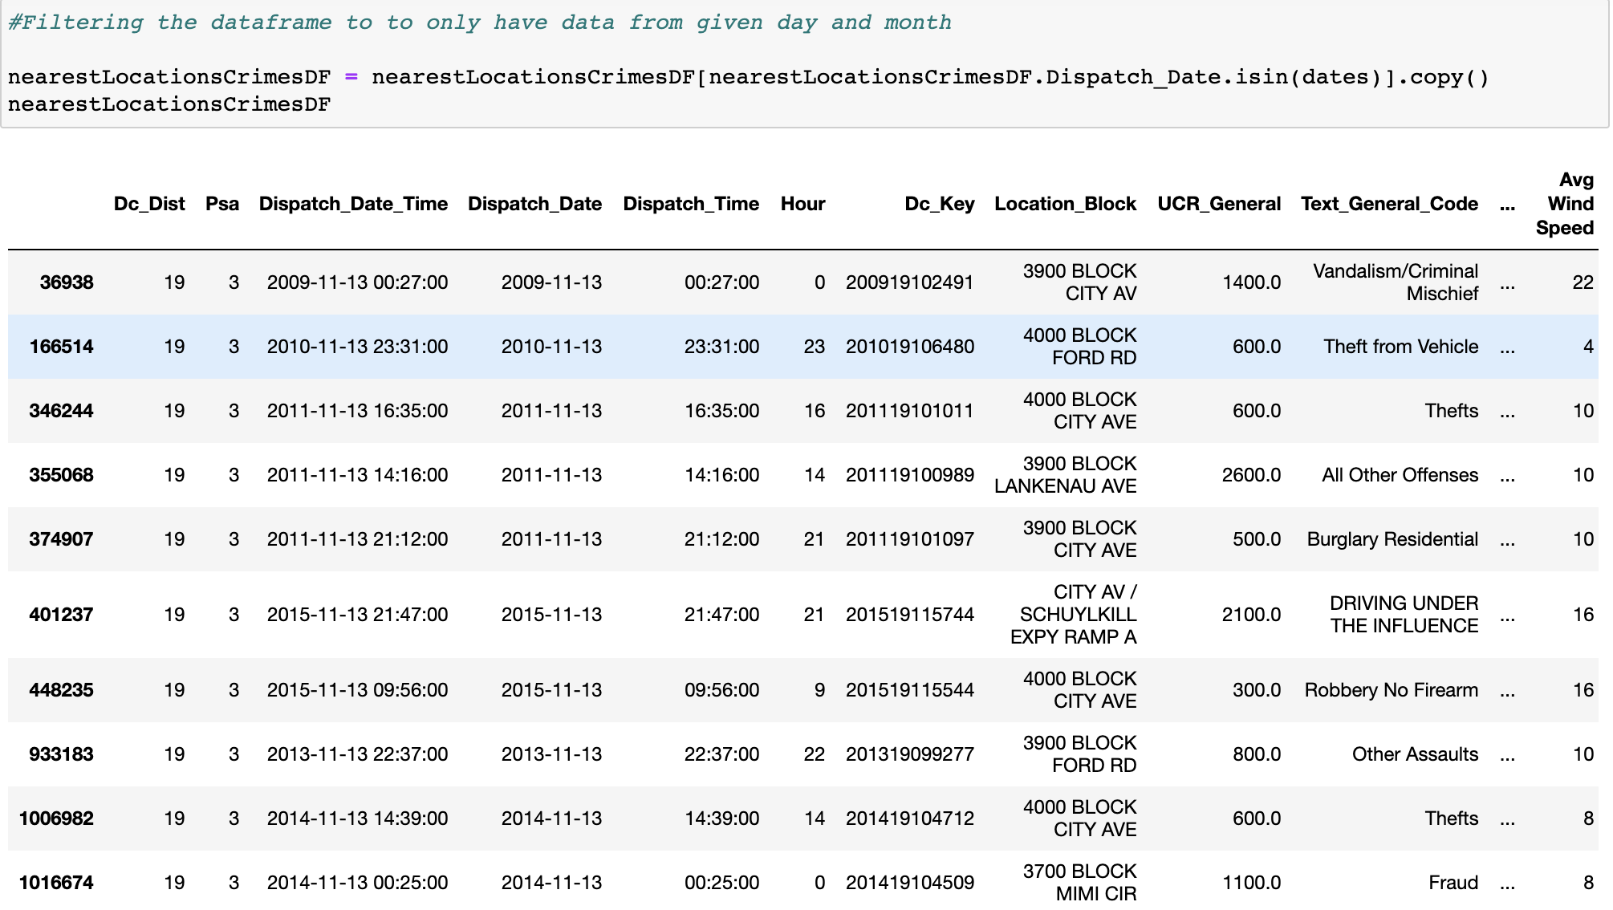

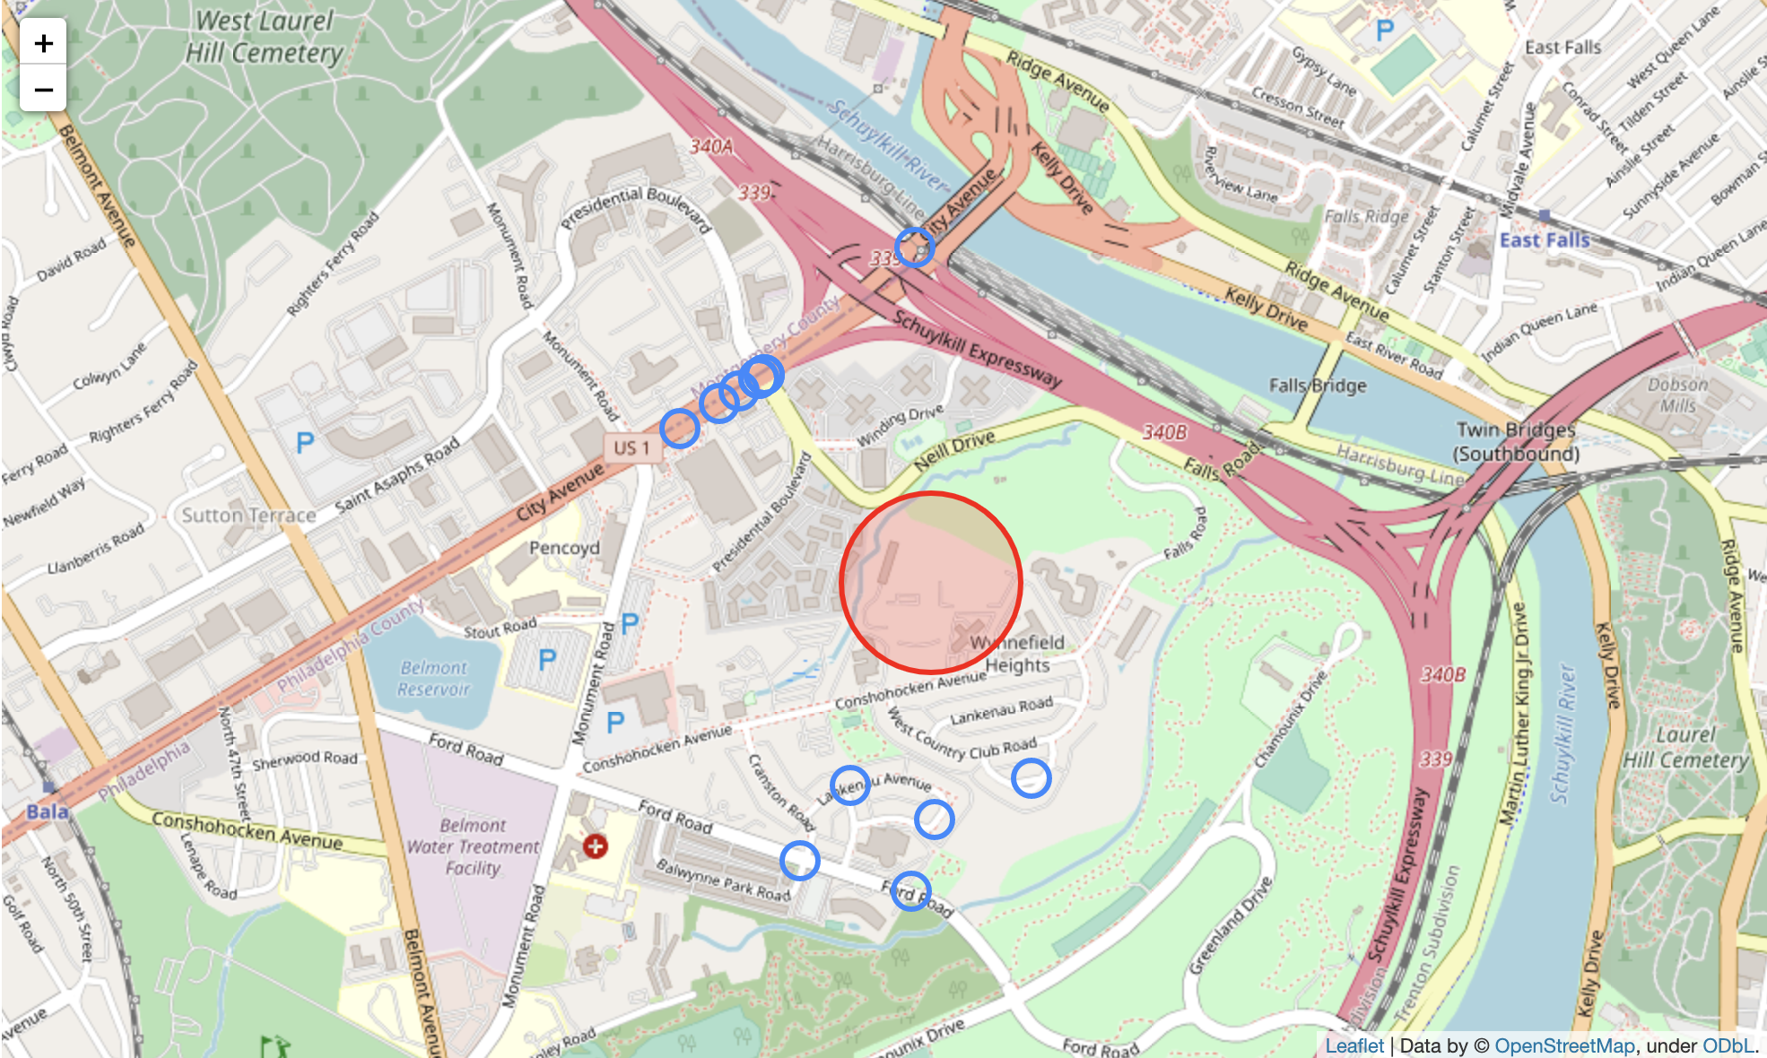

The image above contains only the nearest locations where the crimes have occurred on a user specified date (Nov 11th in this case). In the filtered data frame above based on user specified day and location, we have also achieved essential data about the weather, wind speed, type of crime (violent or non-violent).

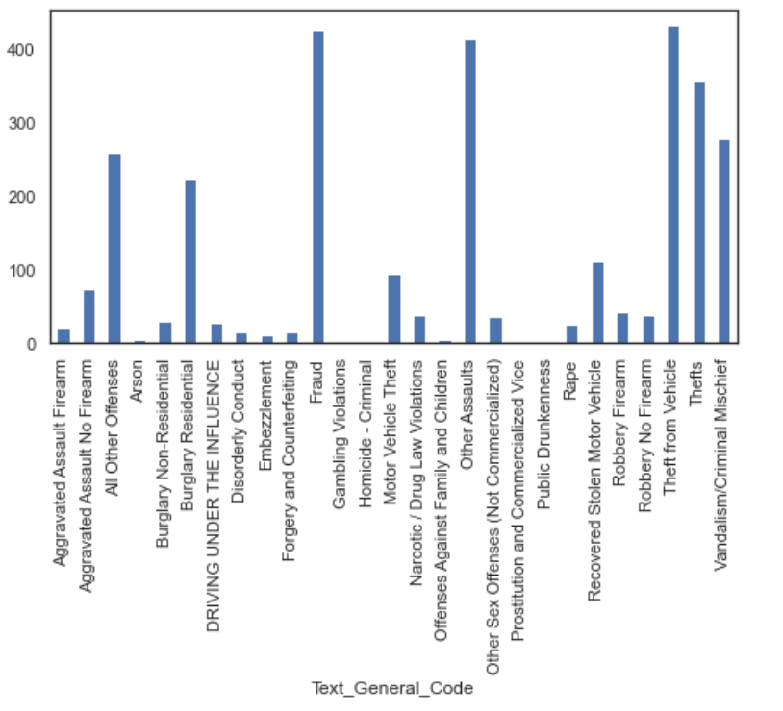

The image above shows the types of crimes that occured for the nearest points to the crime.

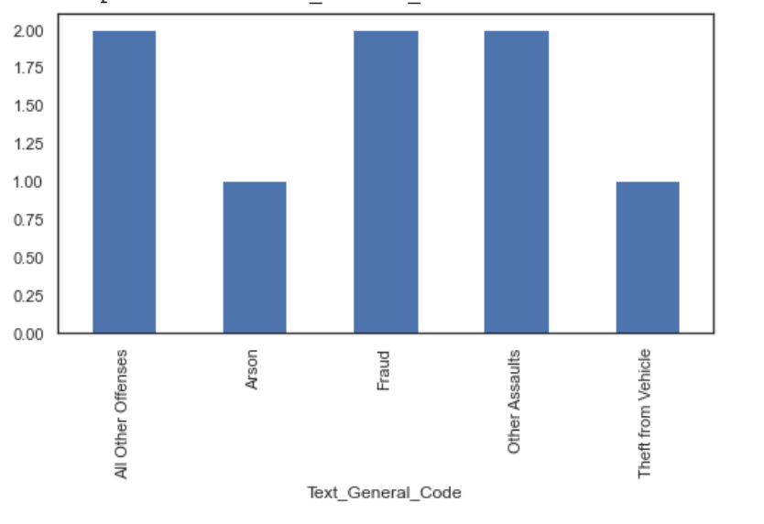

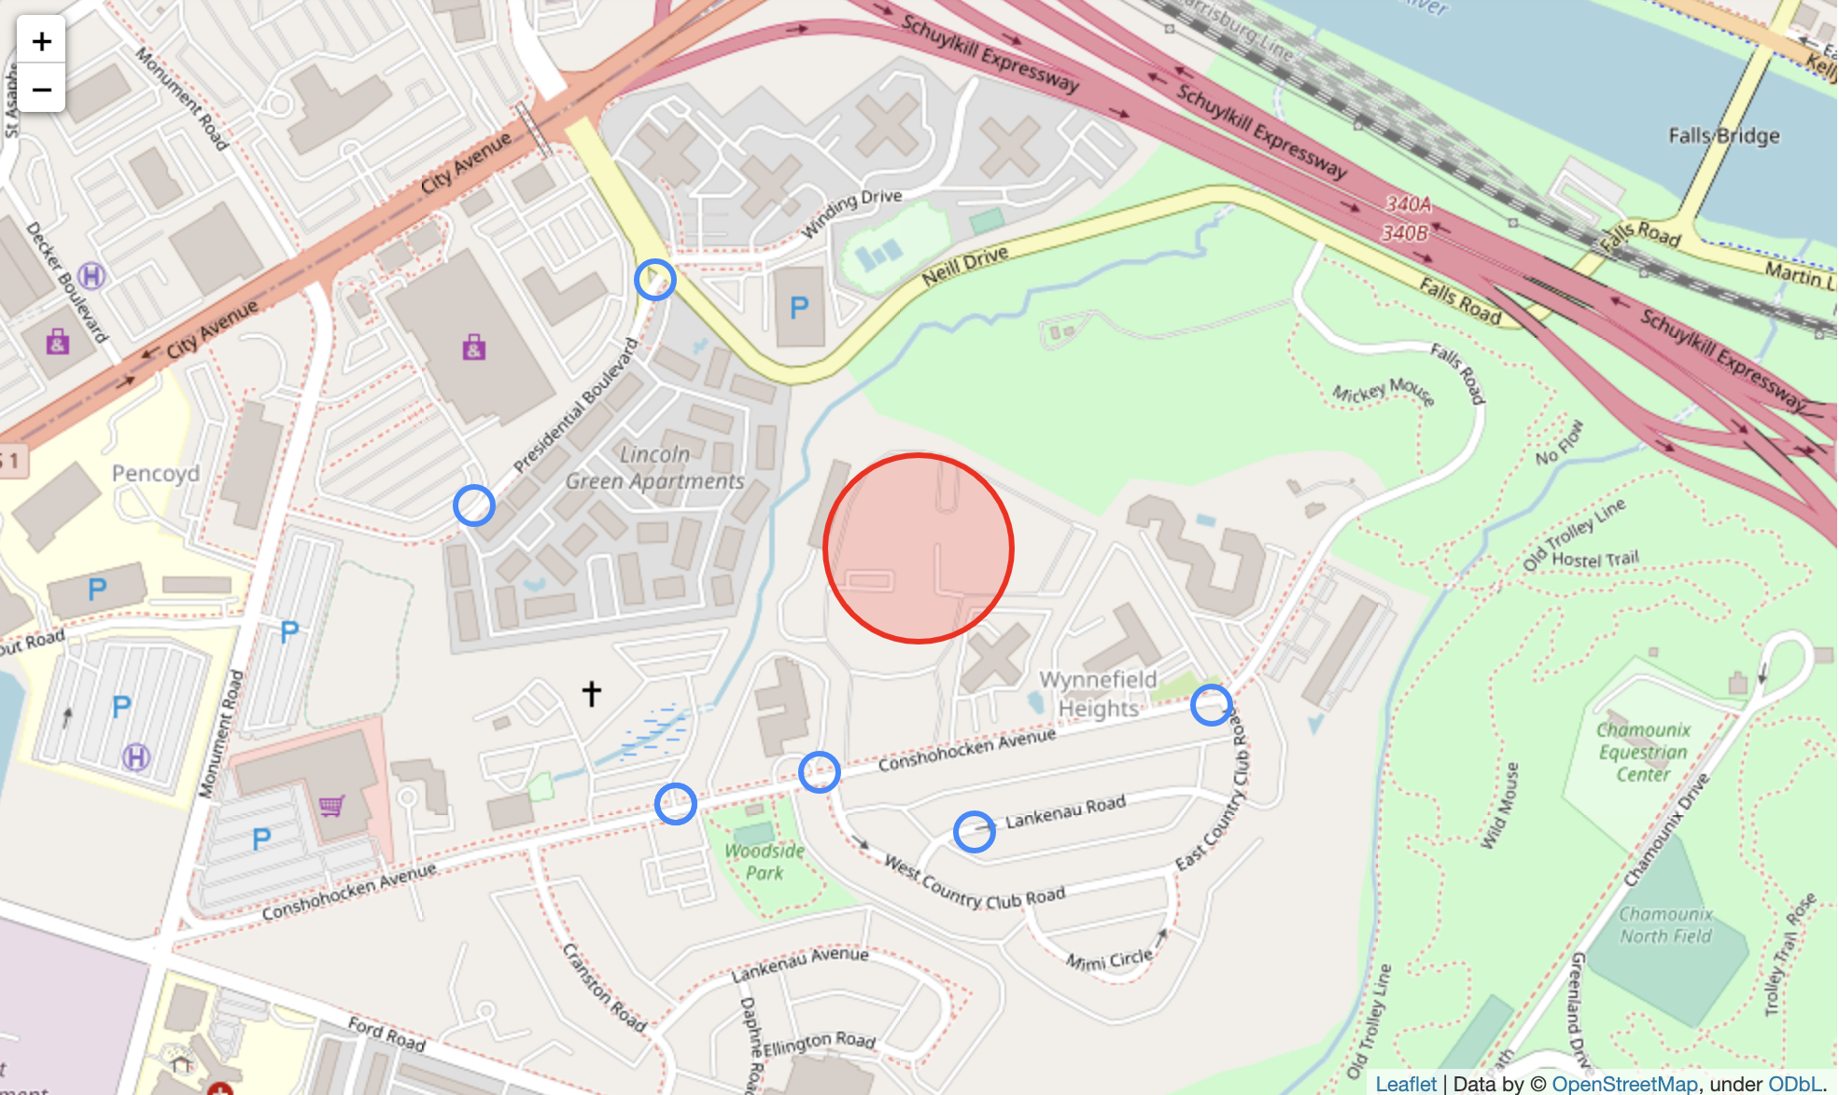

We then filtered down to the crimes that occured on the date (month-day)

Transforming the dataset to have numerical values instead of string.

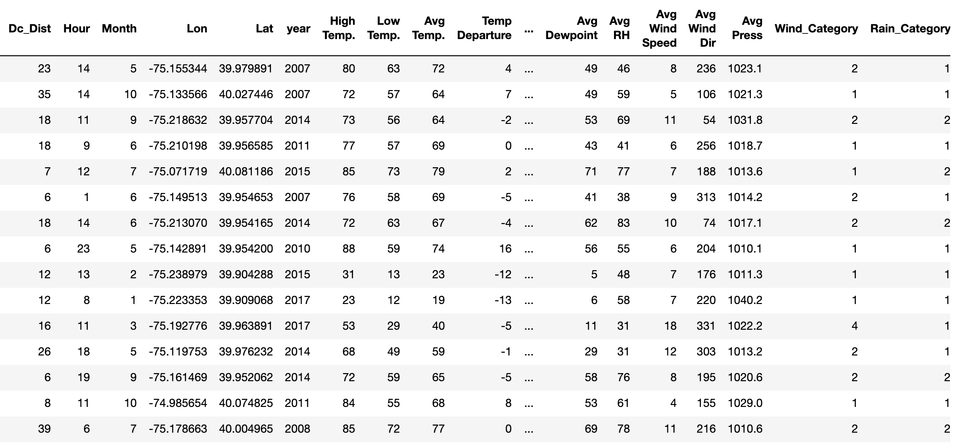

Normalizing the dataset to have values close to or between -1 and 1. (F(x) = (x - mean)/ std)

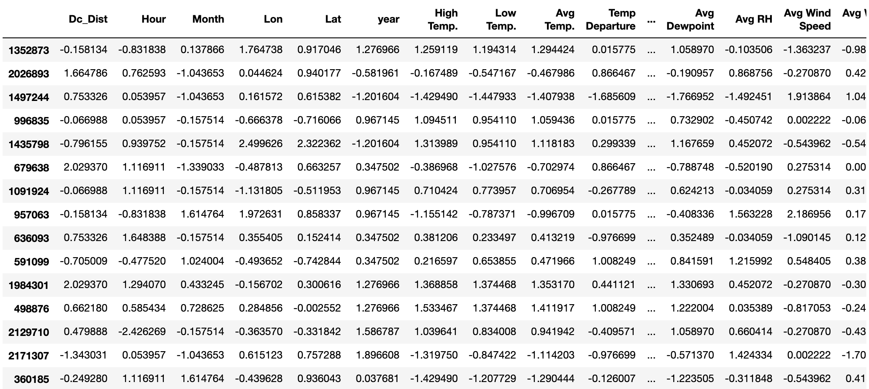

Applying ML classifiers to predict top 5 models and return the accuracy.

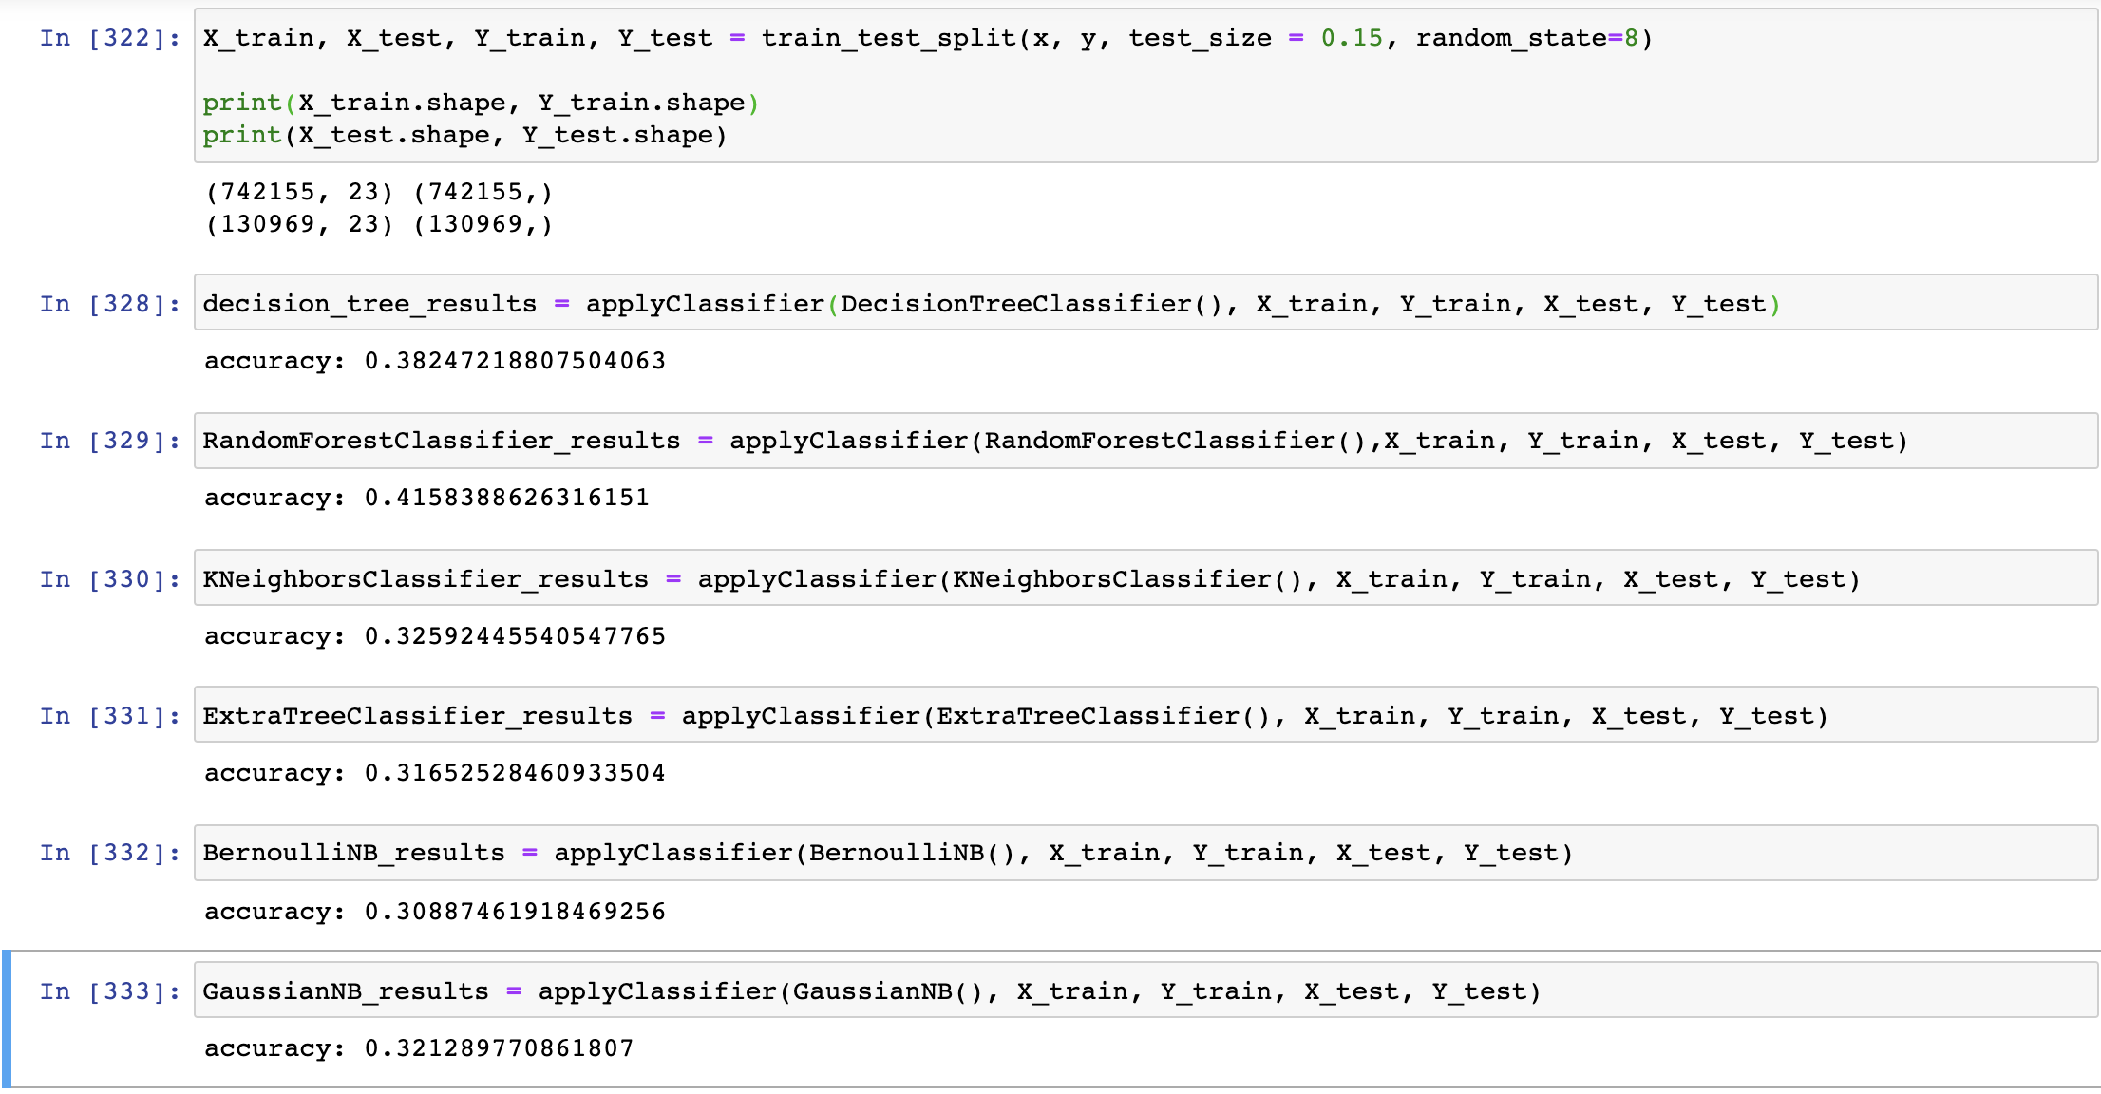

**Appendix**

[Provide the code or pseudo code, and any other information in the appendix here.]

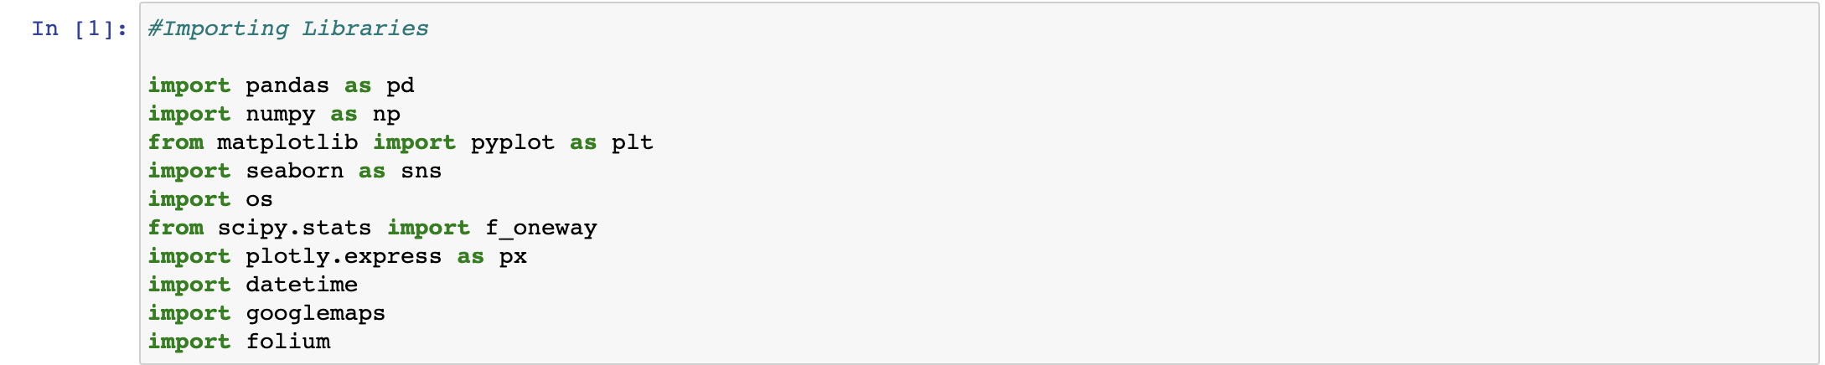

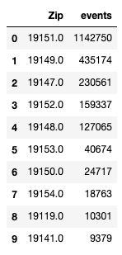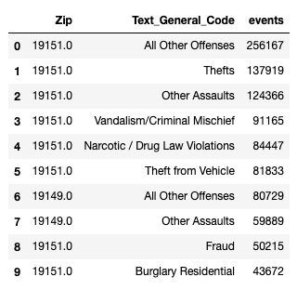

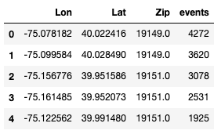

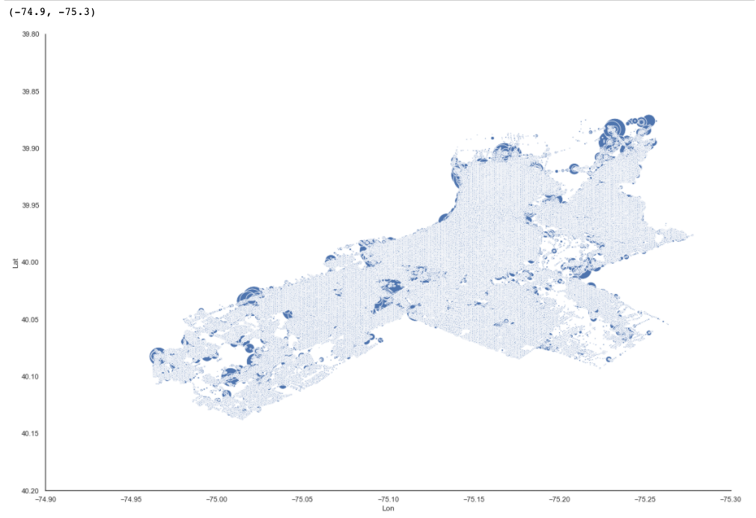

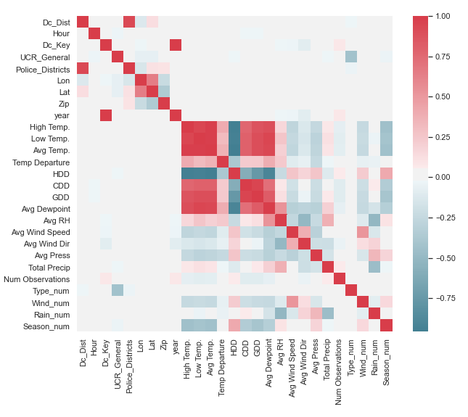

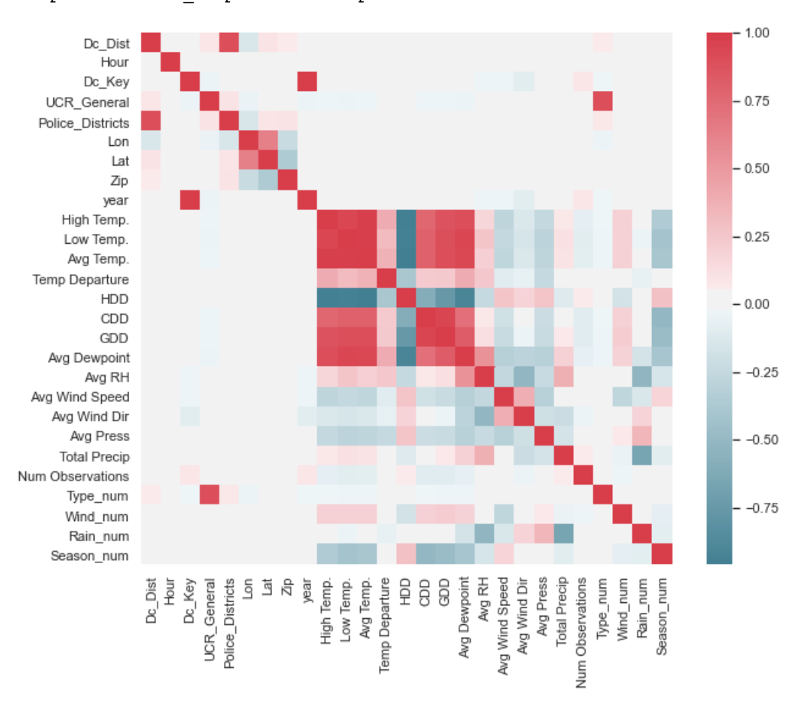

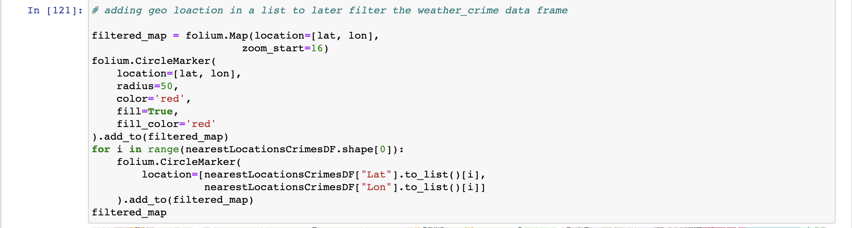

Table of Contributions

The table below identifies contributors to various sections of this document.

|  |  |  |  |
| --- | --- | --- | --- |
|  | **Section** | **Writing** | **Editing** |
| **1** | **Analysis the basic metrics of variables** | **Hong, Kunal** | **Raj** |
| **2** | **Non-graphical and graphical univariate analysis** | **Hong** | **Raj** |
| **3** | **Missing value analysis and outlier analysis** | **Hong, Kunal** | **Raj** |
| **4** | **Feature engineering and analysis** | **Kunal** | **Raj** |
| **5** | **Appendix** | **Kunal** | **Raj** |

**Grading**

The grade is given on the basis of quality, clarity, presentation, completeness, and writing of each section in the report. This is the grade of the group. Individual grades will be assigned at the end of the term when peer reviews are collected.